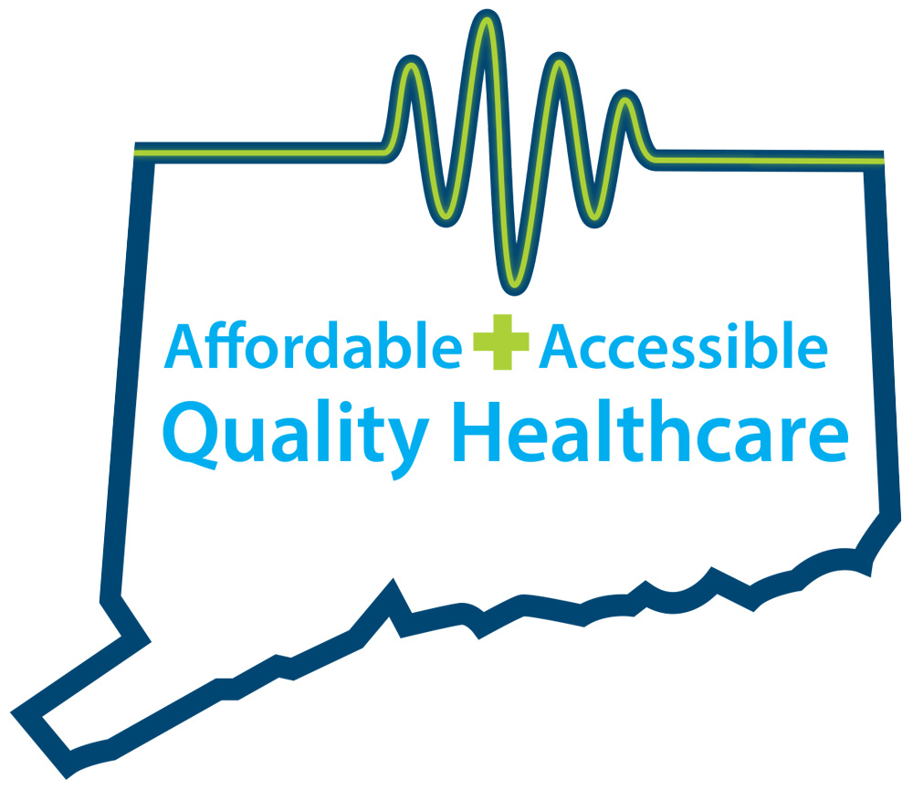
CONNECTICUT AMBULATORY SURGICAL CARE CENTERS
QUALITY, AFFORDABLE, ACCESSIBLE HEALTHCARE

FACT SHEET
About Ambulatory Surgery Centers

OVERVIEW

Ambulatory Surgery Centers―known as ASCs―are modern health care facilities focused on providing same-day surgical care, including diagnostic and preventive health care procedures. ASCs have transformed the outpatient experience for millions of Americans by offering a convenient, personalized, lower-priced alternative to hospitals.

Only 40 years ago, virtually all surgeries and diagnostic procedures were performed in hospitals, requiring waiting periods, costly overnight stays and long recovery periods. As technology has evolved, the same procedures can now be done with minimally invasive techniques and improved anesthesia, allowing patients to return home on the same day as their procedure.

Today, ASCs provide a patient-focused experience in an atmosphere removed from the distractions associated with running a full-service acute care facility.

Since the first physician-led facility was opened in 1970, ASCs have provided patients with a highly specialized, lower-priced alternative to hospital outpatient surgical services. On average, Medicare pays ASCs half of what it pays to hospital outpatient facilities for the same procedure. Those savings are passed on to patients and insurers, including Medicare and Medicaid, in the form of lower health care spending and co-payments.

ASCs also add considerable value to the US economy, with an estimated nationwide economic impact of $90 billion, including more than $5.8 billion in tax payments. Additionally, ASCs employ the equivalent of about 117,700 full-time workers.
(Source: Oxford Outcomes ASC Impact Analysis, 2010.)

CONVENIENCE AND ACCESS

There are more than 5,400 Medicare-certified ASCs in the United States.

ASCs focus on outpatient surgical and diagnostic procedures, with ASC patients reporting a 92 percent satisfaction rate.

As essential Medicare providers of surgical and cancer screening services, ASCs perform more than 40 percent of all Medicare colonoscopies, contributing to a decade-long decrease in colorectal cancer mortality.

The majority of ASCs are at least partially owned by physicians, which allows for better control over scheduling. As a result, procedures in ASCs are not often delayed or rescheduled due to staffing issues or competing demands for operating room space from emergency cases. Additionally, physicians can personally guide innovative strategies for governance, leadership and quality initiatives.

AMBULATORY SURGERY CENTERS
ASC REGULATION

All ASCs are subject to rigorous oversight and independent inspections to assess each center’s level of compliance with both state and national standards. These on-site surveys, like those conducted at hospitals and other facilities, evaluate ASCs on a wide range of demanding clinical, operational and quality standards.

- State-specific licensure (e.g., ongoing inspection and reporting) is required by most states for ASCs to operate.

- ASCs that treat Medicare beneficiaries must meet federal government standards and demonstrate continual compliance with Medicare’s standards.

- Approximately 68 percent of the industry obtains additional accreditation from several leading organizations, including The Joint Commission and the Accreditation Association for Ambulatory Health Care (AAAHC).

INNOVATIVE PRACTICES

ASCs make valuable contributions to the evolution and improvement of health care by advancing innovations in anesthesia practice, new devices and surgical techniques.

For example, the industry has led the development of minimally invasive procedures and the advancement of technology to replace the intraocular lens. This procedure is now commonly used nearly 1 million times each year to restore vision for Medicare patients with cataracts. Once an inpatient hospital procedure, it can now safely be done at an ASC at a much lower cost.

Content courtesy of the Ambulatory Surgery Center Association. www.ascassociation.org/advancingsurgicalcare

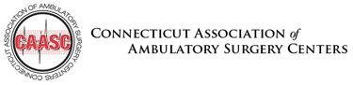 | Contacts:  Lisa Winkler (860.614.6102 or lisa@grassrootsct.com)  Tricia Dinneen Priebe (203.464.3793 or tricia@grassrootsct.com)

