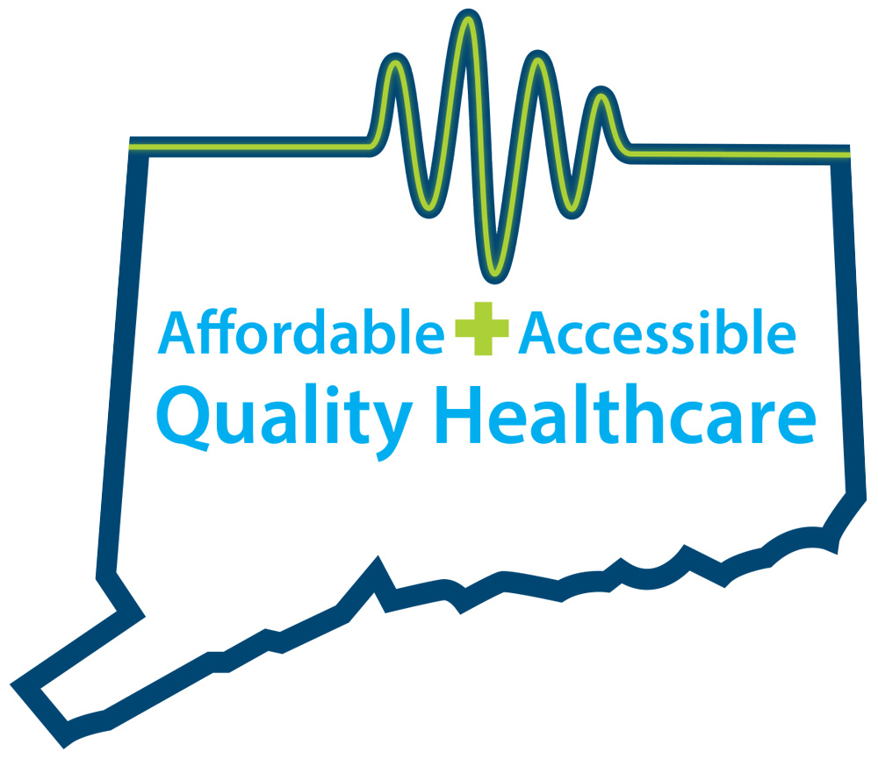
CONNECTICUT AMBULATORY SURGICAL CARE CENTERS
QUALITY, AFFORDABLE, ACCESSIBLE HEALTHCARE

Repeal the Health Care Tax on Ambulatory Surgical Centers
Protect Patient Access to High-Quality, Cost-Effective Surgical Care

About Ambulatory Surgery Centers

Ambulatory Surgery Centers―known as ASCs―are modern health care facilities providing same-day surgical care, including diagnostic and preventive health care procedures that keep rising health care costs in check. These community-based facilities are highly regulated by the state and federal government and save Connecticut patients millions of dollars each year.

ASCs have transformed the outpatient experience for Connecticut citizens by offering convenient, personalized, lower-priced alternatives to hospitals for procedures such cataract surgery, endoscopies, colonoscopies, and more.

Currently, there are 61 facilities in Connecticut providing ambulatory surgical care.

The new health care tax on Connecticut ambulatory surgery centers is unprecedented and unwarranted.

In 2015, the Connecticut General Assembly passed 11th-hour legislation at the close of the session that includes a 6 percent gross receipts tax on ambulatory surgery centers. This “top-line” health care provider tax translates to an effective income tax rate of 30 percent, since it doesn’t allow for deductions for expenses (such as property, sales and use taxes) that are permissible for other types of businesses.

The impact of the tax, which was imposed with no notice, no hearings and no discussion, is unprecedented. Consider the following:

- ASCs allow patients to access care quickly, easily and cost-effectively. These facilities have enabled physicians, surgeons and other health care providers to remain in independent practice, something the Connecticut General Assembly has identified as critical to the state’s health care delivery system.

- Connecticut’s surgery centers employ approximately 2000 people who contribute to the state and local economy. The state Department of Labor identified ambulatory surgical care as an area of employment growth prior to passage of the tax.

- For colonoscopies alone, ASCs saved Connecticut patients $1 million last year in lower co-payments and deductibles. Access to colonoscopy testing has resulted in a decade-long decline in colorectal cancer.

- ASCs save Medicare $2 billion annually because of the lower cost of providing care. ASCs are reimbursed roughly 50% less than hospitals for the same procedures.

Repealing this health care tax is important to Connecticut

The 61 centers providing ambulatory surgical care in communities around the state have invested in state-of-the-art facilities and modern, innovative approaches for improving heath care at lower costs. Many operate as small businesses with thin profit margins. It is quite possible this new health care tax will force 25% of these centers to operate at a loss. They may have no other choice than to close. Already, one ambulatory surgery center shut down.

If this tax is left in place, the result will dramatically decrease patient access to quality, affordable community health care in Connecticut. Health care costs will most certainly rise; patients will pay the price. A February 2016 study from George Mason University’s Mercatus Center contends that taxes on health care providers have “created perverse incentives that discourage efficient care” and are driving up health costs.

In Connecticut, one has only to look at the costs of three common procedures to see that placing this tax burden on ASCs will have unintended consequences of higher health care costs.

Outpatient Surgery | Avg. Hospital Cost | Avg. ASC Cost
Knee or Shoulder | $5,000 | $1,900
Endoscopy | $1,306 | $634
Colonoscopy | $1,611 | $754
Source: Preferred Locations for Ambulatory Surgery Centers, Connecticut Business and Industry Association

This health care tax does more harm than good.

The imposition of this tax was not driven by health care policy, or health equity. It does nothing to further the quality of care or patient access to care. Connecticut should not turn the clock back on the progress we have made in providing for the health and well being of our citizens.

