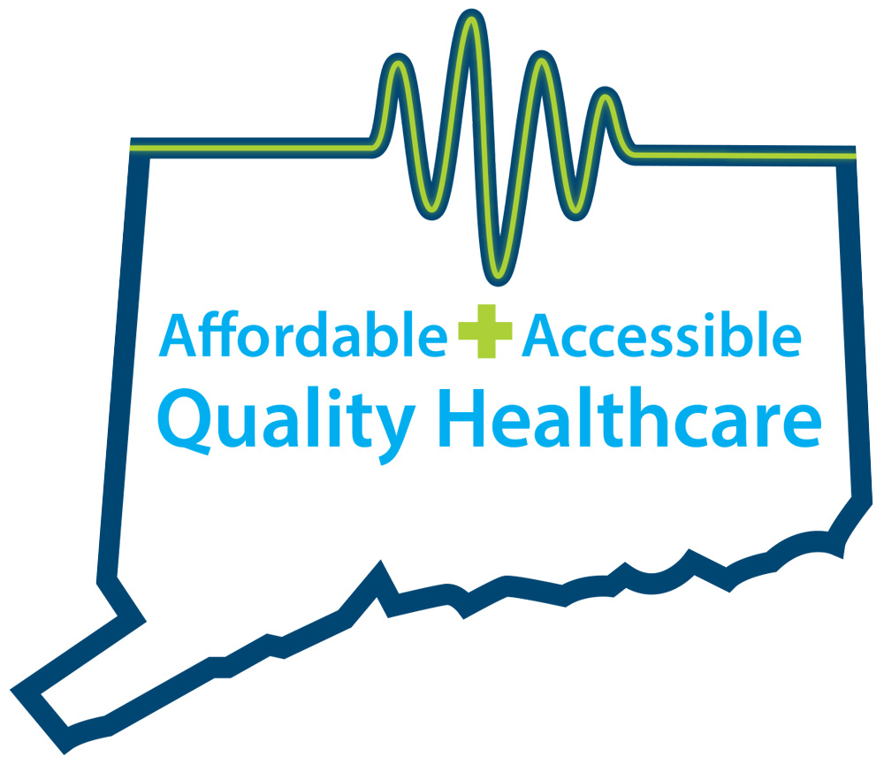
CONNECTICUT AMBULATORY SURGICAL CARE CENTERS
QUALITY, AFFORDABLE, ACCESSIBLE HEALTHCARE

FACT SHEET
Connecticut Ambulatory Surgery Centers

Connecticut’s 61 ambulatory surgical care facilities are located in all corners of the state. They offer quality patient-focused surgical care and considerable cost savings to both patients and health insurers, compared to traditional hospital surgeries. They play an important role in the economy of our state.

In Connecticut, a procedure at an ambulatory surgery center can cost less than half of what the same procedure would cost at a hospital:

Outpatient Surgery | Avg. Hospital Cost | Avg. ASC Cost
Knee or Shoulder | $5,000 | $1,900
Endoscopy | $1,306 | $634
Colonoscopy | $1,611 | $754

Source: Preferred Locations for Ambulatory Surgery Centers, Connecticut Business and Industry Association

- ASCs perform about 200,000 medical procedures in Connecticut each year, in settings that allow doctors to exercise greater control over the surgical experience than in a hospital—because they focus on a specialized group of surgical procedures.

  - The most common procedures are cataract surgeries, colonoscopies, endoscopies and orthopedic procedures.

- Data from 2012 shows that Connecticut patients saved more than $1 million in health insurance co-pays by electing to have colonoscopies in ASCs. (Source: ASCA)

- In 2012, Connecticut ASCs saved Medicare $8.8 million on cataract surgeries, and more than $1.5 million on 1,300 arthroscopic knee and shoulder surgeries. (Source: ASCA)

- Private health insurance companies enjoy similar savings when patients choose ASCs, leading to lower healthcare costs for employers.

- ASCs are conveniently located for patients—allowing Connecticut residents to receive high-quality surgical services in their local communities.

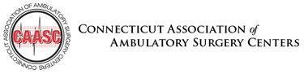 | Contacts:  Lisa Winkler (860.614.6102 or lisa@grassrootsct.com)  Tricia Dinneen Priebe (203.464.3793 or tricia@grassrootsct.com)

