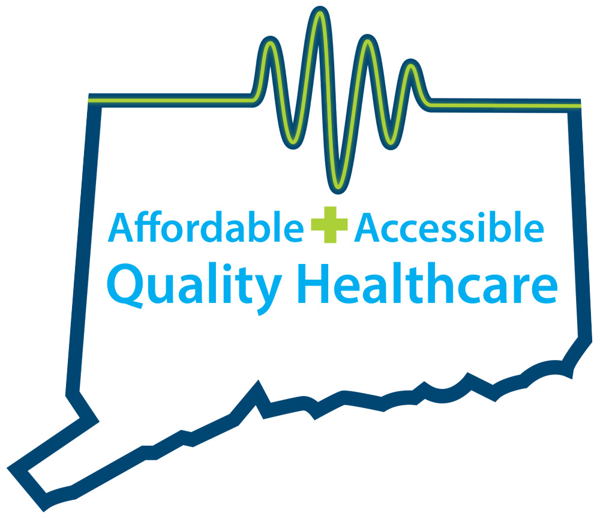
CONNECTICUT AMBULATORY SURGERY CENTERS
QUALITY, AFFORDABLE, ACCESSIBLE HEALTHCARE

ISSUE OVERVIEW

SB 10, An Act Concerning Revenue Items to Implement the Governor’s Budget: Connecticut’s Healthcare Provider Tax on Ambulatory Surgery Centers

In 2015, the Connecticut General Assembly passed 11th-hour legislation at the close of the session that included a 6 percent gross receipts tax on ambulatory surgery centers. This tax translates to an effective income tax rate of 30 percent, as it does not allow for deductions for expenses, such as property, sales and use taxes. The impact of the tax is unprecedented and has a considerable negative impact on ambulatory surgery centers across the state.

In its current form, this bill would impose an additional tax of $60,000 to every ambulatory surgery center in the state by eliminating the $1 million exemption currently in the statute. Unlike hospitals, ASCs already pay taxes like other small businesses: state income tax, sales tax, and property tax. An ASC should be taxed like any other small business OR taxed like a non-profit care provider—but not both.

Ambulatory surgery centers are a critical component of Connecticut’s health care delivery system and a significant economic engine for the state. Outpatient care centers (such as ambulatory surgery centers) have been projected to grow by more than 39 percent between 2014 and 2024, according to the Connecticut Department of Labor. Their data shows our industry has the highest projected growth rate of any in the state.

If this tax is left in place, it will push some ASCs to operate at a loss, resulting in potential closures. Without a viable low-cost option, patients will be forced to seek care at more expensive surgery settings. Surgery centers that remain in operation will likely be forced to cut back on the services they provide and forgo innovations they can pursue when they are less able to invest in new equipment and advanced technologies.

This tax will increase healthcare costs. One has only to look at the costs of three common procedures to see that placing this tax burden on ASCs will have unintended consequences of higher healthcare costs if those procedures must be done in a hospital setting.

Outpatient Surgery | Avg. Hospital Cost | Avg. ASC Cost
Knee or Shoulder | $5,000 | $1,900
Endoscopy | $1,306 | $634
Colonoscopy | $1,611 | $754
Source: Preferred Locations for Ambulatory Surgery Centers, Connecticut Business and Industry Association

The Connecticut Association of Ambulatory Surgery Centers and its members are committed to providing the highest quality healthcare at a lower cost. The best thing the legislature can do to protect the growing industry of ambulatory surgical care and its significant contributions to Connecticut’s economy is to repeal the ambulatory surgery center tax. Taking into consideration the state’s fiscal situation, the immediate need is to stabilize the industry and keep these small businesses alive. For this legislative session, that means:

- Limiting the tax to apply to ambulatory surgical center services, not revenue related to equipment and materials required to perform those services;
- Ensuring a waiver is granted by CMS that maintains a $1 million exemption;
- Excluding Medicaid and Medicare revenues from the tax; and
- Reducing the tax rate (a 6% tax is the highest in the nation).

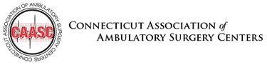 | Contacts:  Lisa Winkler - 860.614.6102 or lisa@grassrootsct.com  Tricia Dinneen Priebe - 203.464.3793 or tricia@grassrootsct.com

